CSE 3323 Lab

**Motor Speed Control**

For this lab, we will control motor speed and direction by changing the duty cycle of the power applied to the motor. The variable duty cycle waveform will be generated by a function generator. A H-bridge motor driver will buffer the function generator output to drive the motor. The big picture block diagram follows. Note that current direction through the motor determines the direction of motor rotation, and average motor current determines the motor speed and torque.

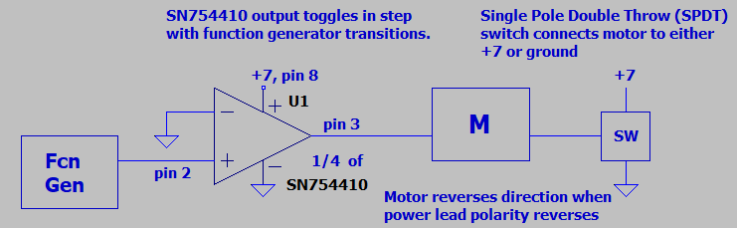

The schematic of the circuit follows. Note that there are many connections to ground.

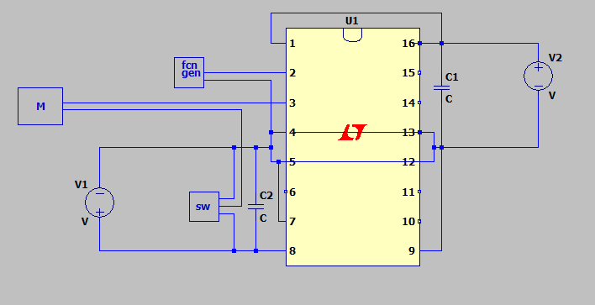

The SN754410 H-bridge driver (Texas Instruments) is effectively an amplifier, taking input from function generator on pin 2, and pulling its output (pin 3) high (to V1 on pin 8, minus Vsat) when the digital input is logic high. Output on pin 3 is pulled low (ground + Vsat) when the input is logic low. Vsat = 1.4-1.8V for the SN754410 driver. Motor direction is determined by the direction of current flow. Motor speed is adjusted via the duty cycle. Note that the motor averages the current, being largely inductive. Higher average current results in higher speed and torque. This will be discussed in the lab. The second supply (pin 16) powers the digital circuits in the SN754410. This supply determines the logic levels for the digital input on pin 2.

The block diagram of the L293 driver follows: **Note: We are using equivalent SN754410**

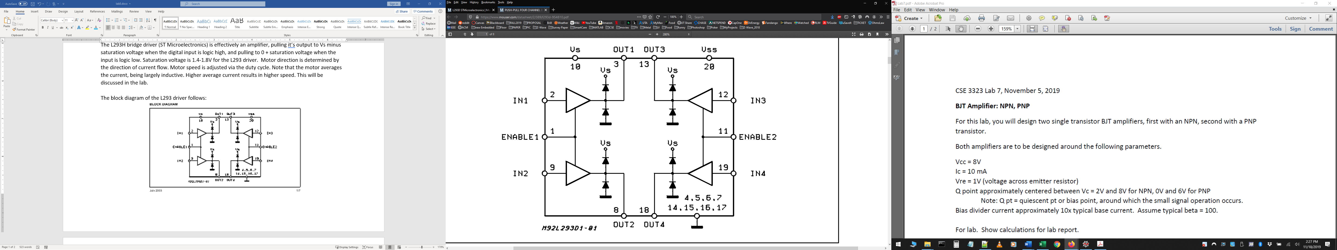

Note that the L293D driver IC contains 4 drivers, we will enable two (enable 1) and use just one (input on pin2 output on pin 3). L293D output 1 feeds one lead from the motor, the other lead connects to a SPDT (single pole, double throw) switch, which connects one motor lead to either Vs or ground. This switch controls the direction of the motor while motor speed is controlled by the duty cycle of the waveform from the function generator.

The L293D has 2 supply inputs, one for the digital control circuits (Vss), the other (Vs) powers the output stage which drives the load. The pinout for the 16 pin DIP version of the driver is shown below.

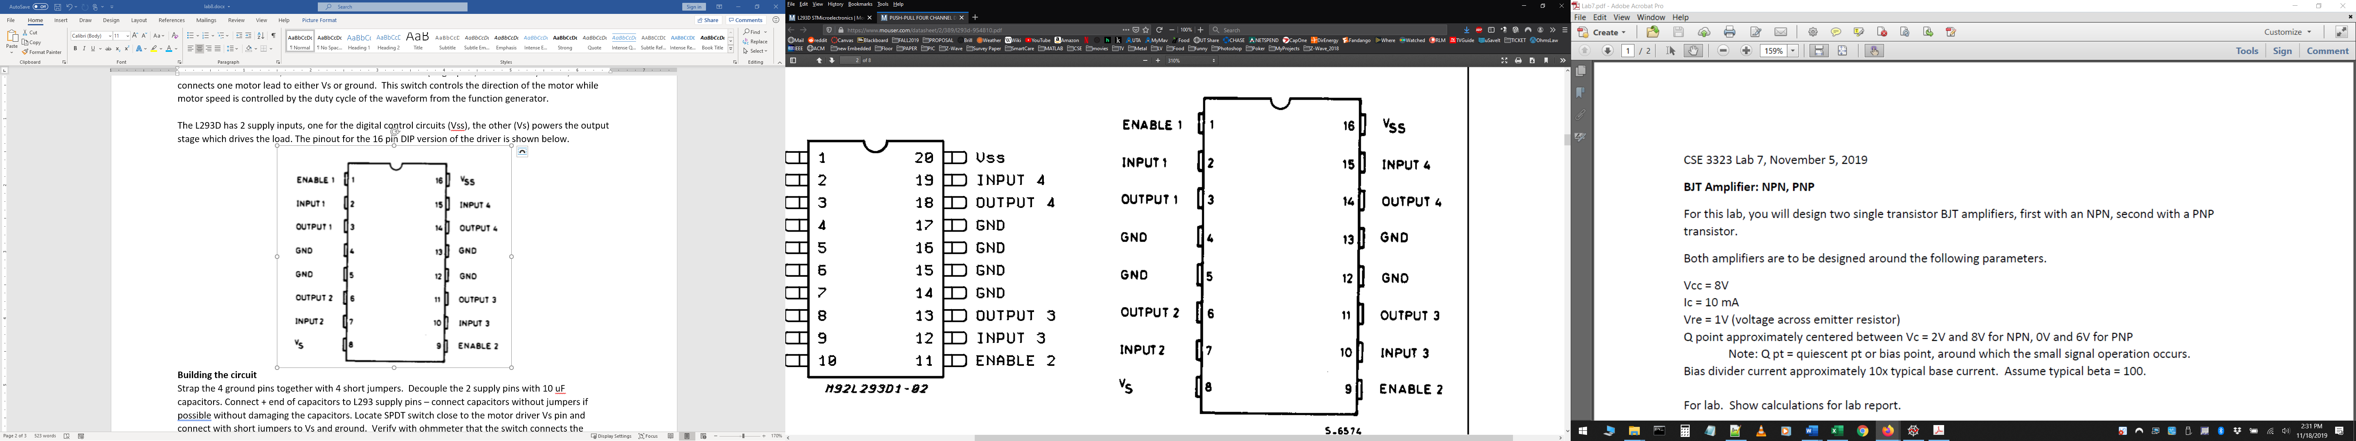

**Building the circuit**

Define a ground rail and jumper every pin that needs to be grounded to this rail. The negative lead of both capacitors connects to this rail as does one lead from the switch, one lead from each of the two power supplies, and one lead from the function generator. Decouple the 2 supply pins with 10 uF capacitors. Connect + end of capacitors to L293D supply pins – connect capacitors without jumpers if possible without damaging the capacitors. Locate SPDT switch close to the motor driver Vs pin and connect with short jumpers to Vs and ground. Verify with ohmmeter that the switch connects the motor lead to either Vs or to ground.

**Setup**

Adjust fcn generator for 1KHz square wave approximately 50% duty cycle, 0V min amplitude, 5V max amplitude. Set Vs supply for 500 mA current limit, Vss supply for 60 mA current limit. Start with Vs = 7V (pin 8), Vss = 5V (pin 16). With both supplies on, the motor should be running. A flip of the switch should reverse the direction.

1. Check output 1 (pin3) with the oscilloscope with duty cycle around 50% . What is output 1 voltage range with the motor running “forward“? When reversed? Explain how voltages can exceed +7 V or be less than 0 V.

Forward V = -2V to 13.6 V

Reversed V = -2V to 9 V

Voltage can exceed 7 or be lower than 0, because the voltage reference changes at some point in the circuit. From 7 to 5 the change is -2 volts and 7 plus 5 go up to 12 volts, thus providing the ranges for this circuit and motor.

TA said something about Inductance in circuit! Idk

1. Relative to the function generator output, when do the output voltage excursions (>7 or <0) occur? - that is during transitions or the steady state high or low periods?

The output voltage excursions happen at the beginning of both steady states, the high and low.

1. Verify speed can be adjusted by varying the duty cycle of the waveform from the function generator.
2. What duty cycle results in max speed in the “fwd” direction? When reversed?

Forward Max Speed @ 20%

Reversed Max speed @ 80%

**Theory**

Motors have complicated models, but all have inductance.

1. Given the properties of an inductor, what would you expect to happen to the voltage between motor leads if the motor was open circuited while significant motor current was flowing?
2. Given the above, can you explain the reason for the diodes in the block diagram of the driver?